29th Annual SLAPT Physics Contest

Washington University in St. Louis

April 26, 2014

Comprehensive Physics Test

$g=9.8 \frac{\text{m}}{{\text{s}}^{2}}$ $e=1.6×{10}^{9}\text{C}$ $1{\text{cm}}^{3}=\text{millimeter}$
$R=8.314 \frac{\text{J}}{\text{mol∙K}}$ $c=3.0×10^{8}\frac{\text{m}}{\text{s}}$ $\text{Coulomb constant, k=8.99 × }{10}^{9}\frac{\text{N}{\text{m}}^{2}}{{\text{C}}^{2}}$

Please answer the following questions on the supplied answer sheet. You may write on this test
booklet and keep it for your records. Only the answer sheets will be scored.

Your answer sheets must have your name, your school, and MECHANICS on them

The cash prizes for this exam will be:
First Prize of $100, Second Prize of $50, and Third Prize of $25.

Newton Awards will be presented to the next highest scoring twenty percent of the contestants,
and certificates to the top three scoring schools.

Award Ceremony at approximately 12:30 in this room

- An atomic mass unit is approximately equal to the mass of a(n):
- alpha particle
- electron
- photon
- positron
- proton

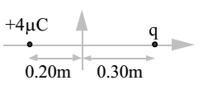
- A point charge of +4.0$μ\text{C}$ is placed on the negative x-axis 0.20 m to the left of the origin, as shown in the accompanying figure. A second point charge q is placed on the positive x-axis 0.30 m to the right of the origin. The net electric field at the origin is zero. What is q?
- +9$μ\text{C}$
- +6.0$μ\text{C}$
- 0
- -6.0$μ\text{C}$
- -9.0$μ\text{C}$

- A mass “m” attached to a horizontal massless spring with spring constant “k” is set into simple harmonic motion. Its maximum displacement from its equilibrium position is “A”. What is the mass’s speed as it passes through its equilibrium position?

- 0

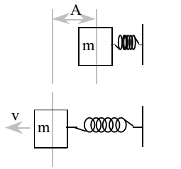

- An arrow is aimed horizontally, directly at the center of a target 20 m away. The arrow hits 0.050 m below the center of the target. Neglecting air resistance, what was the initial speed of the arrow?

A. 20 m/s B. 40 m/s C. 100 m/s D. 200 m/s E. 400 m/s

- You are given three 1.0 Ω resistors. Which of the following equivalent resistances CANNOT be produced using all three resistors?

A.1/3 Ω B.2/3 Ω C.1.0 Ω D.1.5 Ω E.3.0 Ω

- An electroscope is given a positive charge, causing its foil leaves to separate. When an object is brought near the top plate of the electroscope, the foils separate even further. We could conclude
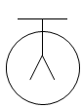
- that the object is positively charged.
- that the object is electrically neutral.
- that the object is negatively charged.
- only that the object is charged.
- only that the object is uncharged.

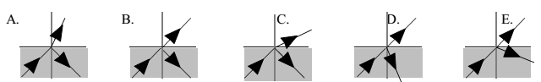
- Which diagram best represents what happens to a ray of light entering air from water? Air is at the top in all diagrams.

- A 3.0-kg block with initial speed 4.0 m/s slides across a rough horizontal floor before coming to rest. The frictional force acting on the block is 3.0 N. How far does the block slide before coming to rest?

A. 1.0 m B. 2.0 m C. 4.0 m D. 8.0 m E. 16 m

- A narrow beam of monochromatic light enters a lens parallel to the optic axis, as shown in the accompanying diagram. Which arrow best represents the direction of the light after leaving the lens?
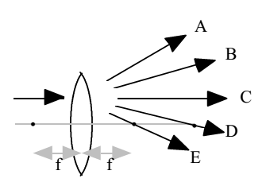

- A
- B
- C
- D
- E

- A 5000-kg freight car moving at 4.0 km/h collides and couples with an 8000-kg freight car which is initially at rest. The approximate common final speed of these two cars is

A. 1.0 km/h B. 1.3 km/h C. 1.5 km/h D. 2.5 km/h E. 4.0 km/h

- Originally there are N atoms of an unstable isotope. After 20 minutes, only 1/16 of them have not decayed. What is the half-life of the isotope?

A. 10 minutes B. 5 minutes C. 4 minutes D. 2 minutes E. 1 minute

- Two large oppositely charged insulated plates have a uniform electric field between them. The distance between the plates is increased. Which of the following statements is true?
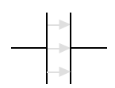
I. The field strength decreases.
II. The field strength increases.
III. The potential difference between the plates increases.

A. I only B. II only C. III only D. I and III only E. II and III only

- A student performs the Photoelectric Effect Experiment and obtains the data depicted in the accompanying graph of E_{Km} the maximum kinetic energy of the photoelectrons in eV, versus f, the frequency of the photons is 10⁺¹⁴ Hz. What is the approximate work function for this material?

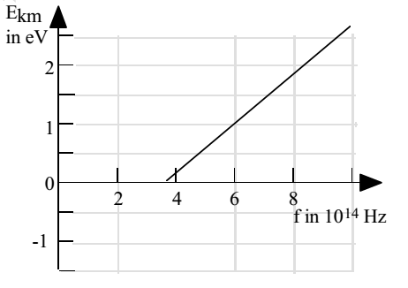

- 1.5 eV
- 2.0 eV
- 2.7 eV
- 4.0 eV
- 6.0 eV

- Two wave pulses approach each other as seen in the figure to the right. The wave pulses overlap at point P. Which diagram best represents the appearance of the wave pulses as they leave point P?
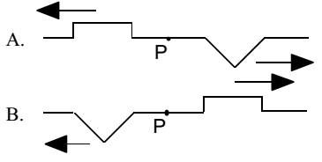
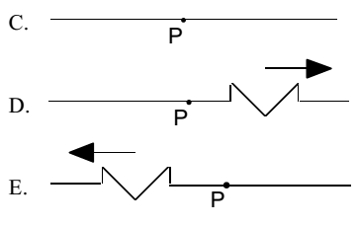
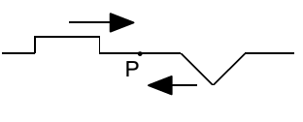

- A simple pendulum of mass m and length L has a period of oscillation T at angular amplitude $θ = 5^{°}$measured from its equilibrium position. If the amplitude is changed to $10°$ and everything else remains constant, the new period of the pendulum would be approximately:

A. $2T$ B.$\sqrt{2}T$ C.$T$ D.$T/\sqrt{2}$ E.$T/2$

- A potassium ${}_{19}^{40}{\text{K}}$ emits a $β^{-}$ and becomes:

A.${}_{17}^{37}{\text{Cl}}$ B.${}_{21}^{44}{\text{Sc}}$ C.${}_{18}^{40}{\text{Ar}}$ D.${}_{19}^{40}{\text{K}}$ E.${}_{20}^{40}{\text{Ca}}$

- A force of 10 N stretches a spring that has a spring constant of 20 N/m. The potential energy stored in the spring is:

A. 2.5 J B. 5.0 J C. 10 J D. 40 J E. 200 J

- A 2.0-kg ball is attached to a 0.80 m string and whirled in a horizontal circle at a constant speed of 6.0 m/s. (See the figure). The work done on the ball during each revolution is:
A. 450 J B. 90 J C. 72 J
D. 16 J E. zero
- An isolated conducting sphere of radius R has positive charge +Q. Which graph best depicts the electric field as a function of $r$, the distance from the center of the sphere?
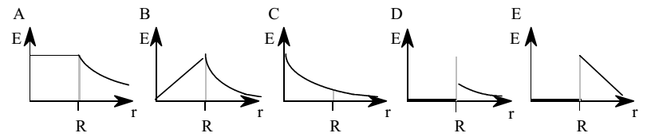

- What temperature change on the Kelvin scale is equivalent to a 10 degree change on the Celsius scale?

A. 283 K B. 273 K C. 18 K D. 10 K E. 0

- In the figure to the right, equipotential lines are drawn at 0, 20.0 V, and 40.0 V. The total work done in moving a point charge of + 3.00 μC from position α to position β is:

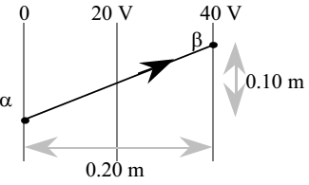
- 4.00 μJ
- 8.00 μJ
- 12.0 μJ
- 24.0 μJ
- 120 μJ

- A 0.20 m long copper rod has constant velocity 0.30 m/s traveling through a uniform magnetic field of 0.060 T. The rod, velocity, and magnetic field are all mutually perpendicular. What is the potential difference induced across the rod’s length?

A. 0.0036 V B. 0.040 V C. 0.090 V D. 1.0 V E. 25 V

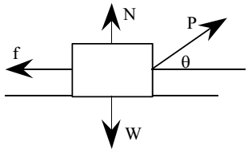
- A student pulls a wooden box along a rough horizontal floor at constant speed by means of a force P as shown to the right. Which of the following must be true?

- P > f and N < W
- P > f and N = W
- P = f and N > W
- P = f and N = W
- P < f and N = W

- Two boxes are accelerated to the right on a frictionless horizontal surface as shown. The larger box has a mass of 9 kilograms and the smaller box has a mass of 3 kilograms. If a 24 newton horizontal force pulls on the larger box, with what force does the larger box pull on the smaller box?
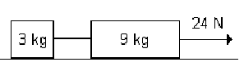
A. 3 N B. 6 N C. 8 N
D. 18 N E. 24 N

- A heating coil is rated 1200 watts and 120 volts. What is the maximum value of the current under these conditions?

A. 10.0 A B. 12.0 A C. 14.1 A D. 0.10 N E. 0.141 A

- A 50 kilogram skater at rest on a frictionless rink throws a 2 kilogram ball, giving the ball a velocity of 10.0 m/s. Which statement describes the skater’s subsequent motion?

- 0.4 m/s in the same direction as the ball.
- 0.4 m/s in the opposite direction to the ball.
- 2 m/s in the same direction as the ball.
- 4 m/s in the same direction as the ball.
- 4 m/s in the opposite direction to the ball

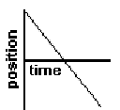
- What is the shape of the velocity time graph for an object with the position time graph shown in the diagram at right?

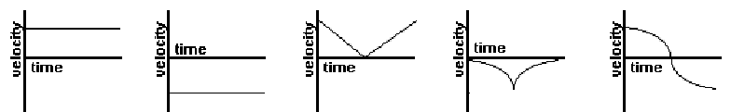

A B C D E

- The following equation is an example of what kind of nuclear reaction?
$${}_{92}^{235}{\text{U}}+ {}_{0}^{1}n→ {}_{51}^{133}{\text{Sb}}+ {}_{41}^{99}{\text{Nb}}+4{}_{0}^{1}n$$

A. fission B. fusion C. alpha decay D. beta decay E. positron decay

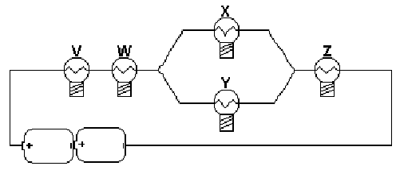
- The diagram at right represents a simple electric circuit composed of 5 identical light bulbs and 2 flashlight cells. Which bulb (or bulbs) would you expect to be the brightest?

- V only
- V and W only
- V and Z only
- V, W and Z only
- all five bulbs are
- the same brightness

- Two masses are connected by a string which passes over a frictionless, massless pulley. One mass hangs vertically and one mass slides on a 30 degrees incline. The vertically hanging mass is 4.0 kg and the mass on the frictionless incline is 6.0 kg. The acceleration of the 4.0 kg mass is,

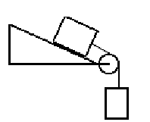
- 0.98 m/s²
- 3.92 m/s²
- 5.75 m/s²
- 6.86 m/s²
- 7.84 m/s²

- The graph shows the force in x direction on an object as it moves a distance x. What is the work done by the force when the object moves from 0.0 m to 6.0 m?
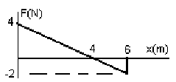
- 14 J
- 12 J
- 10 J
- 8 J
- 6 J

- The explosion in a cannon exerts an average force of 30,000 N for L meters, the length of the cannon. The length of the cannon to shoot a 2.0 kg projectile from the cannon on the earth to the moon is,

A. 2.75 km B. 3.01 km C. 3.98 km D. 4.26 km E. 5.02 km

- A sound source of 100 watts radiates sound uniformly in all directions. The intensity of the sound at a distance of 4.0 m is,

- 0.250 W/m²
- 0.353 W/m²
- 0.497 W/m²
- 0.535 W/m²
- 0.625 W/m²

- A longitudinal wave travels on a slinky or any long spring. The wave is represented by the equation: f(x,t) = (2.1cm) cos[ (2000 rad/s) t + (40 m⁻¹) x]. What is the velocity of the wave?

- 50 m/s in the + x direction.
- 50 m/s in the – x direction.
- 200 m/s in the + x direction.
- 200 m/s in the – x direction.
- 2.1 cm/s in the + x direction

- A projectile is launched from the ground at an angle of 65º above horizontal with an initial speed of 40.0 m/s. The projectile lands 80.0 m away on the horizontal surface above a cliff as shown. What is the height of the cliff?

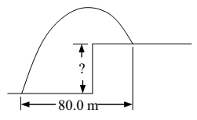
- 13.4 m
- 37.3 m
- 52.9 m
- 61.8 m
- 80.0 m

- 20.0 g of ice at −10.0 °C are added to 100. g of water at 80.0 °C in an insulated container. The specific heat of ice is 0.48 cal/(g·C°), the specific heat of liquid water is 1.00 cal/(g·C°), and the heat of fusion of water is 80. cal/g. What is the equilibrium temperature of this mixture?

A. 0.0 °C B. 53 °C C. 58 °C D. 66 °C E. 72 °C

- A finely machined surface has a large number of identical uniformly-spaced parallel grooves. When a laser that emits radiation of wavelength 632 nm illuminates the surface in a direction perpendicular to the surface, a bright reflection occurs in a direction 60.0º away from the perpendicular to the surface. What is the minimum spacing of the grooves on the machined surface?

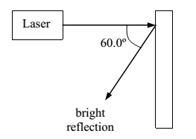
- 316 nm
- 632 nm
- 730 nm
- 948 nm
- 1264 nm

- Thallium 204, atomic mass 203.973839 u, decays to lead 204, atomic mass 203.973020 u, with a half-life 3.78 years. What is the rate of decay of thallium 204 that must occur to release 3.00 mW of power? (1 u = 1.6605 × 10⁻²⁷ kg)

- A. 1.93 × 10⁶ s⁻¹
- B. 2.45 × 10¹⁰ s⁻¹
- C. 4.50 × 10¹² s⁻¹
- D. 3.84 × 10¹³ s⁻¹
- E. 5.12 ×10¹⁴ s⁻¹

USE THIS DIAGRAM FOR THE NEXT TWO QUESTIONS
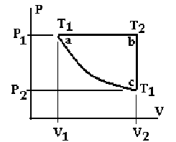
- The PV diagram for one mole of an ideal gas is shown in the figure above. P1 = 3 atm, P2 = 1 atm, V1 = 7 liters, and V2 = 21 liters. What is the temperature T1 at point a?

A. 256 K B. 200 K C. 175 K D. 115 K E. 100 K

- One mole of an ideal gas undergoes an isometric process from point b to point c in the figure above. P1 = 3 atm, P2 = 1 atm, V1 = 7 liters, and V2 = 21 liters. What is the work done by or on the system?

- 0J
- 2,740 J
- 4,260 J
- 6,380 J
- 7,230 J

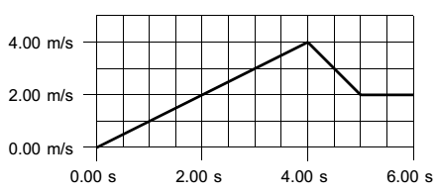
- A graph of velocity as a function of time is shown for the rectilinear motion of an object. What is the magnitude of the displacement of the object during the 6.0 s interval shown in the graph?

- 9.0 m
- 12.0 m
- 13.0 m
- 17.0 m
- 20.0 m

- A binary star system consists of star A with a mass 4.00 ×10³⁰ kg and star B with a mass 8.00 ×10³⁰ kg orbiting each other in elliptical orbits. When the two stars are 5.00 ×10⁹ m apart, their total kinetic energy is 2.00 ×10⁴¹ J. How far apart are the two stars when their total kinetic energy is 3.00 ×10⁴¹ J?

- 2.22 ×10⁹ m
- 3.33 ×10⁹ m
- 4.05 ×10⁹ m
- 7.50 ×10⁹ m
- 1.13 ×10¹⁰ m

- A 12.0 kg rectangular block of material is 20.0 cm by 30.0 cm by 40.0 cm. The block floats in a liquid so that the 20.0 cm edge is vertical and 4.00cm of that edge is above the surface of the liquid. What is the density of the liquid?

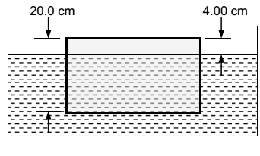
- 300. kg/m³
- 375. kg/m³
- 500. kg/m³
- 625. kg/m³
- 2500 kg/m³

- The expression for $(mass)∙{\left(speed\right)}^{2}/force$ can be reduced to:

A. acceleration B. time C. mass/length D. length E. mass

- A cylinder with radius 0.10 m, mass1.0 kg and moment of inertia 5.00×10⁻³ kg m² starts from rest with center of mass at position A and rolls without slipping along the curved surface shown in the diagram. What is its translational speed when its center of mass reaches position B, 1.50 m below position A?

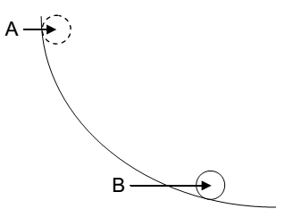

- 7.67 m/s
- 3.13 m/s
- 3.83 m/s
- 4.43 m/s
- 5.42 m/s

- Photons that have a wavelength in vacuum of 119 nm are incident upon a surface whose work function is 4.89 eV. What is the maximum kinetic energy of electrons ejected from this surface?

A. 5.53 eV B. 0.00 eV C. 0.320 eV D. 13.6 eV E. 10.4 eV

- A 400 kg, 8.00 m long uniform beam balances on a fulcrum 3.00 m from the right end as shown in the diagram. What is the mass $m$ placed at the right end of the beam?
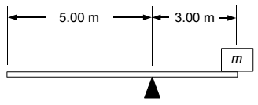
- 50.0 kg
- 66.7 kg
- 100. kg
- 133. kg
- 300. kg

- An electron travels with constant eastward velocity through a region of vertically upward uniform magnetic field 0.300 T and northward uniform electric field 10.0 kV/m. What is the speed of the electron?

- 3.00 × 10³ m/s
- 4.67 × 10³ m/s
- 8.33 × 10³ m/s
- 1.88 × 10⁴ m/s
- 3.33 × 10⁴ m/s

- Unpolarized light with intensity $I_{0}$ traveling toward the east is normally incident on an ideal polarizing film with its axis of polarization tilted 40.0° to the north of vertical. What is the intensity of the light transmitted by the polarizing film?

- $I_{0}$ cos 40.0°
- $I_{0}$cos 50.0°
- $I_{0}$cos² 40.0°
- $I_{0}$cos² 50.0°
- $I_{0}$/2

- A 5.00 Ω resistor and a 30.0 mH inductor are connected in series to a sinusoidal voltage source with an amplitude 26.0 V and an angular frequency 400 s ⁻¹. What is the amplitude of the current in the circuit?

A. 2.00 A B. 3.33 A C. 3.67 A D. 5.20 A E. 130.0 A

